# Table 4.0

|  |  |  |  |  |  |  |  |  |  |  |  |  |  |  |  |  |  |  |  |  |  |  |  |  |  |
| --- | --- | --- | --- | --- | --- | --- | --- | --- | --- | --- | --- | --- | --- | --- | --- | --- | --- | --- | --- | --- | --- | --- | --- | --- | --- |
| 25 Seeds-Group D Concentration 3.125% Seeds 25  Date Began Testing: January/21/2002 | | | | | | | | | | | | | | | | | | | | | | | | | |
| Dish | D-1 | | | | | D-2 | | | | | D-3 | | | | | D-4 | | | | | D-5 | | | | |
| Day | 5 | 7 | 9 | 11 | 13 | 5 | 7 | 9 | 11 | 13 | 5 | 7 | 9 | 11 | 13 | 5 | 7 | 9 | 11 | 13 | 5 | 7 | 9 | 11 | 13 |
| CL |  |  |  |  |  |  |  |  |  |  |  |  |  |  |  |  |  |  |  |  |  |  |  |  |  |
| AH | 2.9 | 3.2 | 3.5 | 4.5 | 5.1 | 2.7 | 3.5 | 3.9 | 4.3 | 4.6 | 3 | 3.4 | 3.6 | 4.1 | 4.3 | 3.1 | 3.5 | 3.9 | 4.5 | 4.9 | 3.2 | 3.6 | 3.7 | 4.3 | 5.1 |
| RL | 1.5 | 2.0 | ↑ | ↑ | ↑ | x | 1.2 | 1.6 | 2.2 | ↑ | .6 | 1.2 | 1.8 | ↑ | ↑ | x | x | 1.1 | 1.3 | 1.6 | x | 1.3 | 2.1 | 2.3 | ↑ |

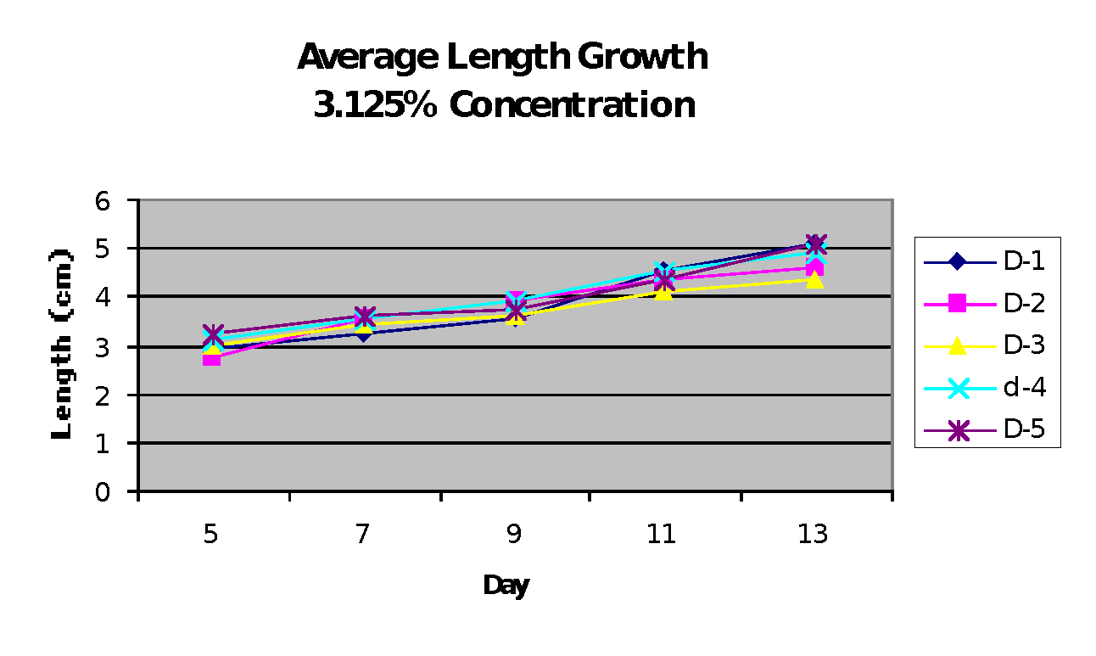**Figure 4.2**